Dear Parents and Students,

Welcome back to school for another exciting year of band! This year will obviously be a little different than usual, but I hope you still consider enrolling. I strongly believe that music is an essential part of the human experience, even more so in times like these, and that it should play a part in everyone’s life.

Once you have filled out and returned this enrolment packet, you will be receiving a band acceptance letter that will include your child’s lesson time and a list of the materials they will need to begin taking lessons. Included with the acceptance letter will be your instrument loan contract, and it will need to be returned within one week of receiving it. Instruments can only be given to students who have returned the signed loan contract. Playing in band can be quite popular in elementary school, and due to a limited number of instruments and to ensure all students have an equal opportunity to participate, instruments are loaned out on a first-come first-serve basis.

Please fill out your registration form and **return it to school by** **Friday, September 25th 2020**

Have your son/daughter give the form to me or his/her classroom teacher as soon as possible. Another option would be to fill out the paperwork from Microsoft Teams or my school website and send a scan or photograph of the completed pages to my email address. **Please label your email** **“Band Enrolment 2020-2021”** and be sure to indicate if your child is a student at Abate or Niagara Street Elementary School.

Musically Yours,

Mr. Michael Kineke, Band Director  
[mkineke@nfschools.net](mailto:mkineke@nfschools.net)

Harry F. Abate Elementary School Mon, Tue, Wed (PM) 278-7960

Niagara Street Elementary School Wed (AM), Thu, Fri 278-5860

**__________________________________________________________________________________________**

**Student Responsibilities** – Students please write your initials next to each statement below to show you are aware of your responsibilities in band.

**I understand that I:**

___ must attend ½ hr. lessons each week on my instrument

___ must ALSO attend band rehearsal each week (this applies to when we return to a normal schedule, you will be informed in your acceptance letter what rehearsals will look like during the hybrid schedule.)

___ am expected to bring all my materials and instrument to every lesson and rehearsal

___ must practice 5 days each week, for 30 minutes each time

___ must turn in my homework at each lesson that is signed by a parent or guardian

Niagara Falls City School District   
Instrumental Music Registration Form

Student Name Classroom Teacher Name Grade #

**Circle the school your child currently attends:**

Abate Niagara Street

**My child has permission to have their photo taken for school purposes:**

YES NO

**Please choose the one that applies to your child by placing an ‘X’ next to it:**

___I would like to be considered for borrowing a school owned instrument this year

___ I own/rent my own instrument and **do not** need to borrow one from my school

___ I want to play percussion or bass guitar and either own my instrument or will purchase it before lessons begin

**Please initial below** next to each statement to indicate you are aware of your responsibility as the parent of a child who  
plays an instrument:

I will sign my child’s homework sheet each week when it is due (the day before their scheduled lesson).

I will provide my child with a quiet, distraction-free space to practice their instrument each day.

I will ensure my child practices for 30 minutes, for 5 days each week.

I will immediately purchase all required materials upon receiving the materials list, or contact Mr. Kineke  
 requesting assistance.

**Parent/Guardian Name (Printed) Parent/Guardian Signature**

**Parent email address(es) Parent phone #(s)**

**Name of instrument your child played last year (if applicable):**

*******If your child did not play an instrument last year, or would like to play a different one from what they’ve played before, please help them fill out the next page so they can find what instrument they would like to try.*******

**Please place a “1” next to your first choice of an instrument, a “2” next to your second choice, and a “3” next to your third choice (if your choice is not clear, an instrument may be chosen for you based on what is still available).**

______Flute ______Saxophone

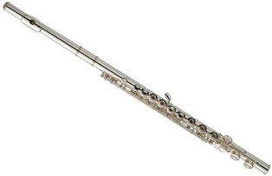 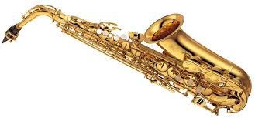

______Trumpet ______Clarinet

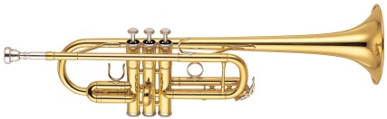 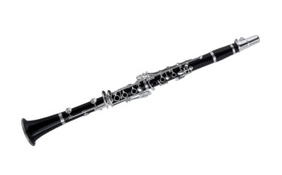

______*Electric Bass Guitar ______ *Percussion (Drums)

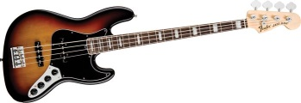 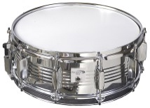

*\*There are NO school-owned bass guitars available. You must own your own in order to take bass guitar lessons. To purchase a bass at a reasonable price, check local music stores, Guitar Center in Amherst, Craigslist.com, Facebook.com, or Goodwill.org.*

*\*\*There are NO school-owned percussion instruments available. All percussion students must buy their own drum sticks and practice pad.*

***Instruments below are ONLY available to 5th and 6th grade students***

______Baritone ______Trombone ______French Horn

